Sending Temperature and Light Data to the Web
GitHub link: https://github.com/NachiketJoy/SIT730/tree/main/Task%202.1P
Circuit Diagram:
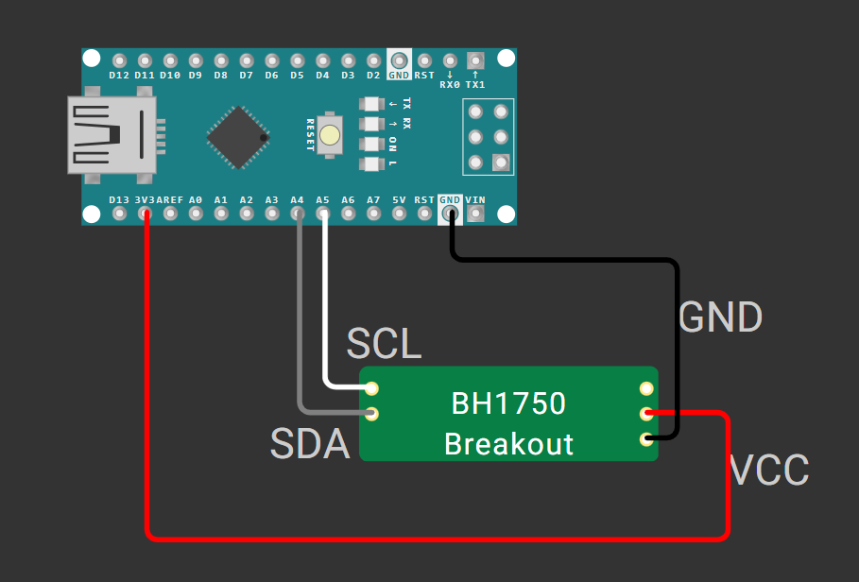

Trigger Mechanism:
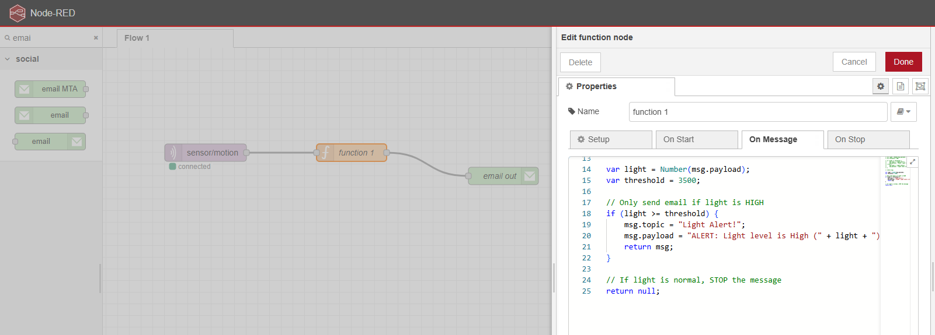
The trigger mechanism is implemented using the Arduino device and Node-RED. The Arduino Nano 33 IoT reads the ambient light intensity using the BH1750 sensor and publishes the lux value to an MQTT topic. Node-RED subscribes to this topic and receives the incoming data in real time.
Within Node-RED, the received value is passed into a Function node, where it is evaluated against a predefined threshold (3500 lux). If the light value exceeds this threshold, the Function node generates and forwards a message. Otherwise, it returns null.
Notification Mechanism:
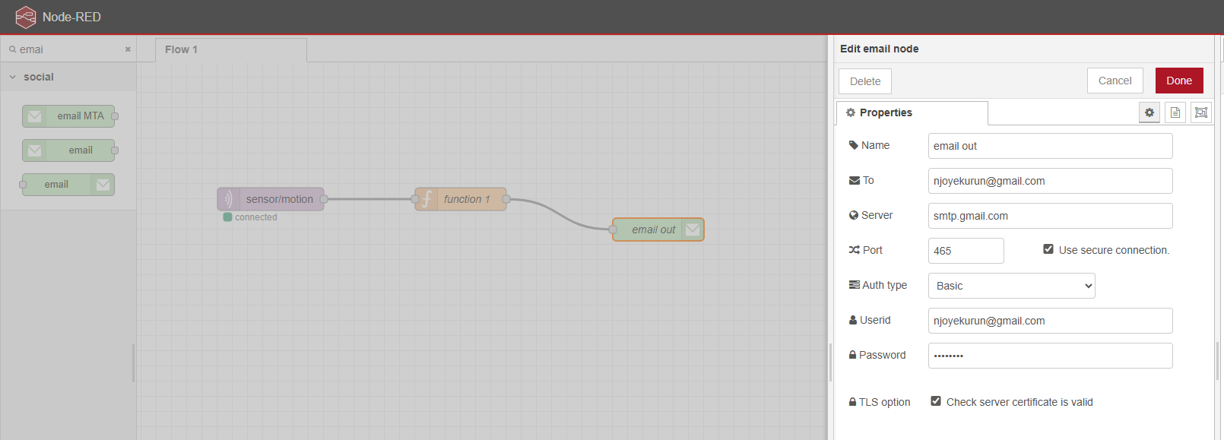
The notification mechanism is handled through Node-RED using an Email node. When the Function node outputs a message, when the threshold condition is met, the Email node receives this message and sends an alert notification.
The email content is generated using msg.topic as the subject and msg.payload as the body of the message. The Email node is configured with Gmail’s SMTP server, enabling it to send notifications to a specified email address. This ensures that the users are alerted immediately when the light intensity exceeds the defined threshold.
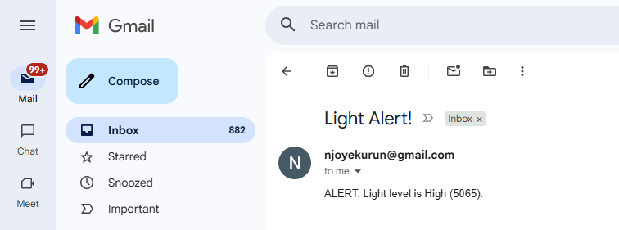
Testing Strategy:
I would verify that the Arduino is correctly reading sensor data by observing the lux values printed in the Serial Monitor. Next, I would ensure that the data is successfully published to the MQTT broker by monitoring the topic using the HiveMQ Web Client. This step validates the communication between the Arduino and the cloud.
Finally, I would test the trigger and notification mechanism by increasing the light intensity by using a flashlight on the sensor. When the lux value exceeds the threshold, the Function node should generate an output, and the Email node should send a notification. By receiving the email, this confirms that the end-to-end system is working correctly.
Use of IFTTT for Device Communication:
Yes, IFTTT can be used to communicate between two Arduino Nano 33 IoT devices. One device (Device A) can send data to IFTTT through a web request or supported service, which then triggers an action that the second device (Device B) can respond to. However, this introduces high latency, depends entirely on the internet, and is not suitable for real-time or continuous data exchange.

